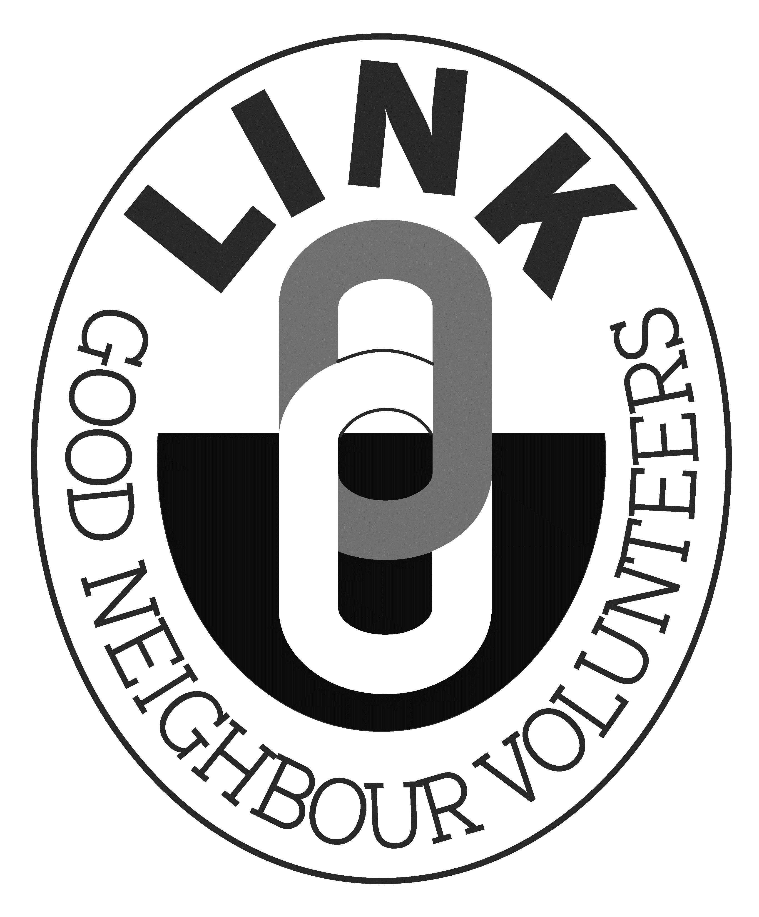
Wiltshire Link Schemes

Donations Guidance

Summary

The intention of this section is to provide guidance to Wiltshire Link Schemes on how they can operate an inclusive and appropriate donations policy that allows all clients to access the service whilst continuing to remain financially sustainable into the future

When setting your donations policy please remember the underlying ethos of the Wiltshire Link Schemes:

‘While no direct charge is made by Wiltshire Link Schemes for the service they deliver, they do depend on the donations they receive in order to continue to operate’

Wiltshire Link Schemes are able to set their own donations policies but must take into account the following principles when setting their donations policy in order to operate to national good practice standards and minimise any associated risk to their schemes.

- Be consistent. What applies to one client, must be applied to all clients

- The support offered is not a means tested service
A client’s ability to donate more cannot and should not be judged or the Link Scheme in question could risk severe legal consequences as a result of operating in a discriminatory way

- Donations must remain confidential from drivers
Not only does this ensure that clients from all financial standings are able to confidently utilise the Link Scheme service but it ensures that drivers are protected against claims of operating for ‘reward and hire’.

If Link Schemes are concerned about the level of donations they are receiving, Community First strongly suggests that Schemes occasionally remind their clients, perhaps on an annual basis, of the cost of running the service and give guidelines outlining suggested donations. Methods which this may be undertaken are:
- Newsletters
- A letter directly to each individual client
- The co-ordinator informing clients from a standard example list
- An announcement at meetings and AGMs.

Community First does not recommend:
- Volunteer drivers directly telling clients the ‘cost’ of a trip/journey
- The carrying of lists which give costs/tariffs to show clients

It is essential that donations are seen as donations and that they cannot be misconstrued as charges, payments or tariffs as this may have an impact on the personal car insurance of the volunteer drivers who may be seen as offering a service from reward and hire. Financial responsibility for the Link Scheme rests with the management committee not its volunteers or clients.

The best way to protect your volunteer drivers against this kind of risk is to ensure that the donations remain anonymous and confidential by having a robust donations policy & procedure in place.

It is recognised and evidenced through the annual audit that Wiltshire Link Schemes are being asked more frequently to support clients to attend medical appointments at hospitals outside of Wiltshire. For most of Wiltshire Link Schemes this has a severe negative financial impact. In order to negate this impact as much as possible, a Link Scheme may implement a policy asking for a ‘minimum donation’ for all journeys over a set mileage (the Link Project suggests 50 miles). This minimum donation must be the exact (or less than) cost of the journey to the Link Scheme.

For example:
The journey is 63 miles round trip
Link Scheme mileage rate = £0.45

The Link Scheme is able to ask for a minimum donation of £28.35

If a Link Scheme decides to implement this guidance, then it must be implemented in full, across ALL clients and not just used for a few clients or those who are seen to be abusing the ‘system’.

Please remember that grants are available and should be utilised to meet the shortfall between donations and costs. In practice donations make up a considerable proportion of the income for most Link Schemes.

A robust and effective donations policy is central to the service provided by a Link Scheme and is also a requirement of the grant aid from the statutory authorities.

